Penyelesaian Persoalan TSP dengan Algoritma

*Branch and Bound*



oleh

**Felix Limanta / 13515065**

**Laporan**

Disusun untuk memenuhi persyaratan nilai mata kuliah

IF2211 – Strategi Algoritma

**Program Studi Teknik Informatika**

**Institut Teknologi Bandung**

**Bandung**

**2017**

# Deskripsi Masalah

This paper. Theoretically, ...

The issue of ...

This paper is organized as follows. The next section presents ... Then, Section 3 discusses

the ... Section 4 analyzes the ... Concluding remarks are offered in Section 5.

# *Source Code*

## SquareMatrix

|  |
| --- |
| **// File : square_matrix.h**  **// Author : Felix Limanta**  **// Date : March 30, 2017**  #include <cstdlib>  #include <iostream>  #include <limits>  **using** **namespace** std**;**  #ifndef SQUARE_MATRIX_H  #define SQUARE_MATRIX_H  **const** **double** INF **=** numeric_limits**<double>::**infinity**();**  **class** SquareMatrix **{**  **private:**  **static** **const** **int** DEF_SIZE**;**  **double\*\*** data**;**  **int** size**;**  **public:**  **class** SquareMatrixRow **{**  **private:**  **double\*** row**;**  **public:**  SquareMatrixRow**(double\*** row**):** row**(**row**)** **{** **}**  **double** **operator[](**size_t index**)** **const** **{**  **return** row**[**index**];**  **}**  **};**  SquareMatrix**(int** size **=** DEF_SIZE**);**  SquareMatrix**(const** SquareMatrix**&** m**);**  **~**SquareMatrix**();**  SquareMatrix**&** **operator=(const** SquareMatrix**&** m**);**  SquareMatrixRow **operator[](**size_t index**)** **const** **{**  **return** SquareMatrixRow**(**data**[**index**]);**  **}**  **friend** ostream**&** **operator<<(**ostream**&** os**,** **const** SquareMatrix**&** m**);**  **void** setData**(**size_t i**,** size_t j**,** **double** data**);**  **double\*\*** getData**()** **const;**  **double** getData**(**size_t i**,** size_t j**)** **const;**  **int** getSize**()** **const;**  **};**  #endif |
| **// File : square_matrix.cpp**  **// Author : Felix Limanta**  **// Date : March 30, 2017**  #include "square_matrix.h"  #include <iostream>  **using** **namespace** std**;**  **const** **int** SquareMatrix**::**DEF_SIZE **=** 20**;**  SquareMatrix**::**SquareMatrix**(int** size**):** size**(**size**)** **{**  data **=** **new** **double*[**size**];**  **for(int** i **=** 0**;** i **<** size**;** **++**i**)** **{**  data**[**i**]** **=** **new** **double[**size**];**  **for** **(int** j **=** 0**;** j **<** size**;** **++**j**)**  data**[**i**][**j**]** **=** 0**;**  **}**  **}**  SquareMatrix**::**SquareMatrix**(const** SquareMatrix**&** m**):** size**(**m**.**size**)** **{**  data **=** **new** **double*[**size**];**  **for(int** i **=** 0**;** i **<** size**;** **++**i**)** **{**  data**[**i**]** **=** **new** **double[**size**];**  **for** **(int** j **=** 0**;** j **<** size**;** **++**j**)**  data**[**i**][**j**]** **=** m**.**data**[**i**][**j**];**  **}**  **}**  SquareMatrix**::~**SquareMatrix**()** **{**  **for** **(int** i **=** 0**;** i **<** size**;** **++**i**)**  **delete** **[]** data**[**i**];**  **delete** **[]** data**;**  **}**  SquareMatrix**&** SquareMatrix**::operator=(const** SquareMatrix**&** m**)** **{**  **if** **(this** **!=** **&**m**)** **{**  **// dtor**  **for** **(int** i **=** 0**;** i **<** size**;** **++**i**)**  **delete** **[]** data**[**i**];**  **delete** **[]** data**;**    **// cctor**  size **=** m**.**size**;**  data **=** **new** **double*[**size**];**  **for(int** i **=** 0**;** i **<** size**;** **++**i**)** **{**  data**[**i**]** **=** **new** **double[**size**];**  **for** **(int** j **=** 0**;** j **<** size**;** **++**j**)**  data**[**i**][**j**]** **=** m**.**data**[**i**][**j**];**  **}**  **}**  **return** **\*this;**  **}**  ostream**&** **operator<<(**ostream**&** os**,** **const** SquareMatrix**&** m**)** **{**  **for** **(int** i **=** 0**;** i **<** m**.**size**;** **++**i**)** **{**  **for** **(int** j **=** 0**;** j **<** m**.**size**;** **++**j**)** **{**  os **<<** m**.**data**[**i**][**j**]** **<<** '\t'**;**  **}**  os **<<** '\n'**;**  **}**  **return** os**;**  **}**  **void** SquareMatrix**::**setData**(**size_t i**,** size_t j**,** **double** data**)** **{**  **this->**data**[**i**][**j**]** **=** data**;**  **}**  **double\*\*** SquareMatrix**::**getData**()** **const** **{**  **return** data**;**  **}**  **double** SquareMatrix**::**getData**(**size_t i**,** size_t j**)** **const** **{**  **return** data**[**i**][**j**];**  **}**  **int** SquareMatrix**::**getSize**()** **const** **{**  **return** size**;**  **}** |

## Node

|  |
| --- |
| **// File : node.h**  **// Author : Felix Limanta**  **// Date : March 30, 2017**  #include "square_matrix.h"  #include <vector>  #ifndef NODE_H  #define NODE_H  **class** Node **{**  **protected:**  **int** id**;**  Node**\*** parent**;**  Node**\*\*** child**;**  vector**<int>** path**;**  **bool\*** visited**;**  SquareMatrix matrix**;**  **double** cost**;**    **public:**  Node**(int** id**,** **const** SquareMatrix**&** m**);**  Node**(int** id**,** **const** SquareMatrix**&** m**,** Node**\*** parent**);**  **virtual** **~**Node**();**    **int** getID**()** **const;**  Node**\*** getParent**()** **const;**  Node**\*\*** getChild**()** **const;**  vector**<int>&** getPath**();**  **bool\*** getVisited**()** **const;**  SquareMatrix**&** getMatrix**();**  **double** getCost**()** **const;**    **virtual** **void** calculateCost**()** **=** 0**;**  **virtual** **void** expandNode**()** **=** 0**;**  **bool** isSolution**();**  **};**  #endif |
| **// File : node.cpp**  **// Author : Felix Limanta**  **// Date : March 30, 2017**  #include "node.h"  Node**::**Node**(int** id**,** **const** SquareMatrix**&** m**):** id**(**id**),** parent**(NULL),** cost**(**0**)** **{**  matrix **=** m**;**  child **=** **new** Node**\*[**m**.**getSize**()];**    path**.**push_back**(**id**);**  visited **=** **new** **bool[**m**.**getSize**()];**  **for** **(int** i **=** 0**;** i **<** m**.**getSize**();** **++**i**)** **{**  visited**[**i**]** **=** **false;**  **}**  visited**[**id**]** **=** **true;**  **}**  Node**::**Node**(int** id**,** **const** SquareMatrix**&** m**,** Node**\*** parent**):** id**(**id**),** parent**(**parent**),** cost**(**0**)** **{**  matrix **=** m**;**  child **=** **new** Node**\*[**m**.**getSize**()];**    path **=** parent**->**path**;**  path**.**push_back**(**id**);**  visited **=** **new** **bool[**m**.**getSize**()];**  **for** **(int** i **=** 0**;** i **<** m**.**getSize**();** **++**i**)** **{**  visited**[**i**]** **=** parent**->**visited**[**i**];**  **}**  visited**[**id**]** **=** **true;**  **}**  Node**::~**Node**()** **{**  **for** **(int** i **=** 0**;** i **<** path**.**size**()** **-** 1**;** **++**i**)**  **delete** child**[**i**];**  **delete** **[]** child**;**  **}**  **int** Node**::**getID**()** **const** **{**  **return** id**;**  **}**  Node**\*** Node**::**getParent**()** **const** **{**  **return** parent**;**  **}**  Node**\*\*** Node**::**getChild**()** **const** **{**  **return** child**;**  **}**  vector**<int>&** Node**::**getPath**()** **{**  **return** path**;**  **}**  **bool\*** Node**::**getVisited**()** **const** **{**  **return** visited**;**  **}**  SquareMatrix**&** Node**::**getMatrix**()** **{**  **return** matrix**;**  **}**  **double** Node**::**getCost**()** **const** **{**  **return** cost**;**  **}**  **bool** Node**::**isSolution**()** **{**  **return** **(**path**.**size**()** **==** matrix**.**getSize**());**  **}** |

## ReducedCostMatrixNode

|  |
| --- |
| **// File : reduced_cost_matrix.h**  **// Author : Felix Limanta**  **// Date : March 30, 2017**  #include "node.h"  #ifndef REDUCED_COST_MATRIX_NODE_H  #define REDUCED_COST_MATRIX_NODE_H  **class** ReducedCostMatrixNode**:** **public** Node **{**  **private:**  **int** subtracted_value**;**    **public:**  ReducedCostMatrixNode**(int** id**,** **const** SquareMatrix**&** m**);**  ReducedCostMatrixNode**(int** id**,** **const** SquareMatrix**&** m**,** ReducedCostMatrixNode**\*** parent**);**    **void** setRowsAndColumnsToInfinite**();**  **void** reduceMatrix**();**  **void** calculateCost**();**  **void** expandNode**();**  **};**  #endif |
| **// File : reduced_cost_matrix.cpp**  **// Author : Felix Limanta**  **// Date : March 30, 2017**  #include "reduced_cost_matrix_node.h"  #include <algorithm>  ReducedCostMatrixNode**::**ReducedCostMatrixNode**(int** id**,** **const** SquareMatrix**&** m**):** Node**(**id**,**m**),** subtracted_value**(**0**)** **{**  reduceMatrix**();**  calculateCost**();**  **}**  ReducedCostMatrixNode**::**ReducedCostMatrixNode**(int** id**,** **const** SquareMatrix**&** m**,** ReducedCostMatrixNode**\*** parent**):** Node**(**id**,**m**,**parent**),** subtracted_value**(**0**)** **{**  setRowsAndColumnsToInfinite**();**  reduceMatrix**();**  calculateCost**();**  **}**  **void** ReducedCostMatrixNode**::**setRowsAndColumnsToInfinite**()** **{**  **for** **(int** i **=** 0**;** i **<** matrix**.**getSize**();** **++**i**)** **{**  matrix**.**setData**(**parent**->**getID**(),** i**,** INF**);**  matrix**.**setData**(**i**,** id**,** INF**);**  **}**  matrix**.**setData**(**id**,** 0**,** INF**);**  **}**  **void** ReducedCostMatrixNode**::**reduceMatrix**()** **{**  **// Subtract row**  **for** **(int** i **=** 0**;** i **<** matrix**.**getSize**();** **++**i**)** **{**  **// Find minimum**  **double** min **=** INF**;**  **for** **(int** j **=** 0**;** j **<** matrix**.**getSize**();** **++**j**)** **{**  **if** **(**matrix**[**i**][**j**]** **!=** INF **&&** matrix**[**i**][**j**]** **<** min**)** **{**  min **=** matrix**[**i**][**j**];**  **}**  **}**    **// Subtract row**  **if** **(**min **!=** INF**)** **{**  **for** **(int** j **=** 0**;** j **<** matrix**.**getSize**();** **++**j**)** **{**  **if** **(**matrix**[**i**][**j**]** **!=** INF**)** **{**  matrix**.**setData**(**i**,** j**,** matrix**[**i**][**j**]** **-** min**);**  **}**  **}**  subtracted_value **+=** min**;**  **}**  **}**    **// Subtract column**  **for** **(int** i **=** 0**;** i **<** matrix**.**getSize**();** **++**i**)** **{**  **// Find minimum**  **double** min **=** INF**;**  **for** **(int** j **=** 0**;** j **<** matrix**.**getSize**();** **++**j**)** **{**  **if** **(**matrix**[**j**][**i**]** **!=** INF **&&** matrix**[**j**][**i**]** **<** min**)** **{**  min **=** matrix**[**j**][**i**];**  **}**  **}**    **// Subtract column**  **if** **(**min **!=** INF**)** **{**  **for** **(int** j **=** 0**;** j **<** matrix**.**getSize**();** **++**j**)** **{**  **if** **(**matrix**[**j**][**i**]** **!=** INF**)** **{**  matrix**.**setData**(**j**,** i**,** matrix**[**j**][**i**]** **-** min**);**  **}**  **}**  subtracted_value **+=** min**;**  **}**  **}**  **}**  **void** ReducedCostMatrixNode**::**calculateCost**()** **{**  cost **=** subtracted_value**;**  **if** **(**parent **!=** **NULL)** **{**  cost **+=** parent**->**getCost**()** **+** parent**->**getMatrix**()[**parent**->**getID**()][**id**];**  **}**  **}**  **void** ReducedCostMatrixNode**::**expandNode**()** **{**  **for** **(int** i **=** 0**;** i **<** matrix**.**getSize**();** **++**i**)** **{**  **if** **(**visited**[**i**])** **{**  child**[**i**]** **=** **NULL;**  **}** **else** **{**  child**[**i**]** **=** **new** ReducedCostMatrixNode**(**i**,**matrix**,this);**  **}**  **}**  **}** |

## CompleteTourWeightNode

|  |
| --- |
| **// File : complete_tour_weight_node.h**  **// Author : Felix Limanta**  **// Date : April 1, 2017**  #include "node.h"  #include <utility>  #ifndef COMPLETE_TOUR_WEIGHT_NODE_H  #define COMPLETE_TOUR_WEIGHT_NODE_H  **class** CompleteTourWeightNode**:** **public** Node **{**  **private:**  pair**<int,int>\*** edges**;**  **bool\*\*** path_m**;**    **public:**  CompleteTourWeightNode**(int** id**,** **const** SquareMatrix**&** m**);**  CompleteTourWeightNode**(int** id**,** **const** SquareMatrix**&** m**,** CompleteTourWeightNode**\*** parent**);**  **~**CompleteTourWeightNode**();**    **void** findMinimumEdges**();**  **void** calculateCost**();**  **void** expandNode**();**  **};**  #endif |
| **// File : complete_tour_weight_node.cpp**  **// Author : Felix Limanta**  **// Date : April 1, 2017**  #include "complete_tour_weight_node.h"  #include <iostream>  CompleteTourWeightNode**::**CompleteTourWeightNode**(int** id**,** **const** SquareMatrix**&** m**):** Node**(**id**,**m**)** **{**  edges **=** **new** pair**<int,int>[**m**.**getSize**()];**  findMinimumEdges**();**  calculateCost**();**  **}**  CompleteTourWeightNode**::**CompleteTourWeightNode**(int** id**,** **const** SquareMatrix**&** m**,** CompleteTourWeightNode**\*** parent**):** Node**(**id**,**m**,**parent**)** **{**  edges **=** **new** pair**<int,int>[**m**.**getSize**()];**  findMinimumEdges**();**  calculateCost**();**  **}**  CompleteTourWeightNode**::~**CompleteTourWeightNode**()** **{**  **delete** **[]** edges**;**  **}**  **void** CompleteTourWeightNode**::**findMinimumEdges**()** **{**  pair**<int,double>** min1**,** min2**;**    **for** **(int** i **=** 0**;** i **<** matrix**.**getSize**();** **++**i**)** **{**  min1 **=** make_pair**(**0**,**INF**);**  min2 **=** min1**;**  **for** **(int** j **=** 0**;** j **<** matrix**.**getSize**();** **++**j**)** **{**  **if** **(**matrix**[**i**][**j**]** **<=** min1**.**second**)** **{**  min2 **=** min1**;**  min1 **=** make_pair**(**j**,**matrix**[**i**][**j**]);**  **}** **else** **if** **(**matrix**[**i**][**j**]** **<=** min2**.**second**)** **{**  min2 **=** make_pair**(**j**,**matrix**[**i**][**j**]);**  **}**  **}**  edges**[**i**]** **=** make_pair**(**min1**.**first**,** min2**.**first**);**  **}**  **for** **(int** i **=** 0**;** i **<** path**.**size**()** **-** 1**;** **++**i**)** **{**  **if** **(**edges**[**path**[**i**]].**first **!=** path**[**i**+**1**])**  edges**[**path**[**i**]].**second **=** path**[**i**+**1**];**  **if** **(**edges**[**path**[**i**+**1**]].**first **!=** path**[**i**])**  edges**[**path**[**i**+**1**]].**second **=** path**[**i**];**  **}**  **}**  **void** CompleteTourWeightNode**::**calculateCost**()** **{**  cost **=** 0**;**  **for** **(int** i **=** 0**;** i **<** matrix**.**getSize**();** **++**i**)** **{**  cost **+=** matrix**[**i**][**edges**[**i**].**first**];**  cost **+=** matrix**[**i**][**edges**[**i**].**second**];**  **}**  cost **/=** 2**;**  **}**  **void** CompleteTourWeightNode**::**expandNode**()** **{**  **for** **(int** i **=** 0**;** i **<** matrix**.**getSize**();** **++**i**)** **{**  **if** **(**visited**[**i**])** **{**  child**[**i**]** **=** **NULL;**  **}** **else** **{**  child**[**i**]** **=** **new** CompleteTourWeightNode**(**i**,**matrix**,this);**  **}**  **}**  **}** |

## TSP

|  |
| --- |
| **// File : tsp.cpp**  **// Author : Felix Limanta**  **// Date : March 31, 2017**  #include "square_matrix.h"  #include "node.h"  #include "complete_tour_weight_node.h"  #include "reduced_cost_matrix_node.h"  #include <algorithm>  **using** **namespace** std**;**  #ifndef TSP_H  #define TSP_H  #define REDUCED_COST_MATRIX 0  #define COMPLETE_TOUR_WEIGHT 1  **struct** Leaf **{**  **double** cost**;**  Node**\*** node_addr**;**    Leaf**(double** cost**,** Node**\*** node_addr**):** cost**(**cost**),** node_addr**(**node_addr**)** **{};**  **};**  **struct** LeafComparator **{**  **bool** **operator()(const** Leaf**&** lhs**,** **const** Leaf**&** rhs**)** **{**  **return** lhs**.**cost **>** rhs**.**cost**;**  **}**  **};**  **class** TSP **{**  **private:**  SquareMatrix matrix**;**  Node**\*** root**;**  vector**<**Leaf**>** leaves**;**  vector**<int>** final_path**;**  **double** final_cost**;**    **public:**  TSP**(int** method**,** **const** SquareMatrix**&** m**);**  **~**TSP**();**    vector**<int>&** getPath**();**  **double** getCost**();**    **void** findPath**();**  **void** expandNode**(**Node**&** n**);**  **};**  #endif |
| **// File : tsp.cpp**  **// Author : Felix Limanta**  **// Date : March 31, 2017**  #include "tsp.h"  TSP**::**TSP **(int** method**,** **const** SquareMatrix**&** m**)** **{**  matrix **=** m**;**  **if** **(**method **==** REDUCED_COST_MATRIX**)** **{**  root **=** **new** ReducedCostMatrixNode**(**0**,** m**);**  **}** **else** **if** **(**method **==** COMPLETE_TOUR_WEIGHT**)** **{**  root **=** **new** CompleteTourWeightNode**(**0**,** m**);**  **}**  leaves**.**push_back**(**Leaf**(**root**->**getCost**(),**root**));**  make_heap**(**leaves**.**begin**(),**leaves**.**end**(),**LeafComparator**());**  **}**  TSP**::~**TSP**()** **{**  **delete** root**;**  **}**  vector**<int>&** TSP**::**getPath**()** **{**  **return** final_path**;**  **}**  **double** TSP**::**getCost**()** **{**  **return** final_cost**;**  **}**  **void** TSP**::**findPath**()** **{**  Node**\*** curr_node**;**  **do** **{**  curr_node **=** leaves**.**front**().**node_addr**;**  pop_heap**(**leaves**.**begin**(),**leaves**.**end**(),**LeafComparator**());**  leaves**.**pop_back**();**      **while** **(!**curr_node**->**isSolution**())** **{**  expandNode**(\***curr_node**);**    curr_node **=** leaves**.**front**().**node_addr**;**  pop_heap**(**leaves**.**begin**(),**leaves**.**end**(),**LeafComparator**());**  leaves**.**pop_back**();**  **}**  **}** **while** **(**matrix**[**curr_node**->**getID**()][**0**]** **==** INF**);**    final_path **=** curr_node**->**getPath**();**  final_cost **=** curr_node**->**getCost**();**  **}**  **void** TSP**::**expandNode**(**Node**&** n**)** **{**  n**.**expandNode**();**    Node**\*\*** child **=** n**.**getChild**();**  **for** **(int** i **=** 0**;** i **<** matrix**.**getSize**();** **++**i**)** **{**  **if** **(**child**[**i**]** **!=** **NULL)**  leaves**.**push_back**(**Leaf**(**child**[**i**]->**getCost**(),** child**[**i**]));**  push_heap**(**leaves**.**begin**(),**leaves**.**end**(),**LeafComparator**());**  **}**  **}** |

## MatrixReader

|  |
| --- |
| **// File : matrix_reader.h**  **// Author : Felix Limanta**  **// Date : March 30, 2017**  #include "square_matrix.h"  #include <string>  **using** **namespace** std**;**  #ifndef MATRIX_READER_H  #define MATRIX_READER_H  **class** MatrixReader **{**  **private:**  SquareMatrix**\*** matrix**;**    **public:**  MatrixReader**(const** string**&** fname**);**  **~**MatrixReader**();**    SquareMatrix getMatrix**()** **const;**  **};**  #endif |
| **// File : matrix_reader.cpp**  **// Author : Felix Limanta**  **// Date : March 30, 2017**  #include "matrix_reader.h"  #include <fstream>  #include <sstream>  MatrixReader**::**MatrixReader**(const** string**&** fname**)** **{**  ifstream inf**;**  inf**.**open**(**fname**,** ios**::**in**);**  string instr**;**    **// Read number of nodes**  **int** size**;**  getline**(**inf**,** instr**);**  istringstream**(**instr**)** **>>** size**;**    **// Read matrix**  matrix **=** **new** SquareMatrix**(**size**);**  **for** **(int** i **=** 0**;** i **<** size**;** **++**i**)** **{**  getline**(**inf**,** instr**);**  istringstream row_in**(**instr**);**  **for** **(int** j **=** 0**;** j **<** size**;** **++**j**)** **{**  **double** n**;**  row_in **>>** n**;**  **if** **(**i **==** j **||** n **<=** 0**)**  n **=** INF**;**  matrix**->**setData**(**i**,** j**,** n**);**  **}**  **}**    inf**.**close**();**  **}**  MatrixReader**::~**MatrixReader**()** **{**  **delete** matrix**;**  **}**  SquareMatrix MatrixReader**::**getMatrix**()** **const** **{**  **return** **\***matrix**;**  **}** |

## GraphVizGenerator

|  |
| --- |
| **// File : graphviz_gnerator.h**  **// Author : Felix Limanta**  **// Date : March 31, 2017**  #include "square_matrix.h"  #include <string>  #include <vector>  #ifndef GRAPHVIZ_GENERATOR_H  #define GRAPHVIZ_GENERATOR_H  **class** GraphVizGenerator **{**  **private:**  **static** **const** string DEF_FNAME**;**  SquareMatrix matrix**;**  **bool\*\*** path_m**;**  **bool** directed**;**  string fname**;**  **double** min_len**;**  **double** max_len**;**  **double** avg_len**;**  **int** n_edge**;**  **public:**  GraphVizGenerator**(const** SquareMatrix**&** m**,** **const** vector**<int>&** path**,**  string fname **=** DEF_FNAME**,** **bool** directed **=** **true);**  **~**GraphVizGenerator**();**  **void** generateDirectedGraph**();**  **void** generateUndirectedGraph**();**  **void** generatePNG**();**  **void** generateSVG**();**  **};**  #endif |
| **// File : graphviz_gnerator.cpp**  **// Author : Felix Limanta**  **// Date : March 31, 2017**  #include "graphviz_generator.h"  #include <cmath>  #include <fstream>  #include <iostream>  #include <sstream>  string remove_extension**(const** std**::**string**&** filename**)** **{**  size_t lastdot **=** filename**.**find_last_of**(**"."**);**  **if** **(**lastdot **==** std**::**string**::**npos**)**  **return** filename**;**  **return** filename**.**substr**(**0**,** lastdot**);**  **}**  **const** string GraphVizGenerator**::**DEF_FNAME **=** "graph"**;**  GraphVizGenerator**::**GraphVizGenerator**(const** SquareMatrix**&** m**,** **const** vector**<int>&** path**,**  string fname**,** **bool** directed**):** directed**(**directed**)** **{**  **this->**fname **=** remove_extension**(**fname**);**  matrix **=** m**;**  path_m **=** **new** **bool*[**m**.**getSize**()];**  **for** **(int** i **=** 0**;** i **<** m**.**getSize**();** **++**i**)** **{**  path_m**[**i**]** **=** **new** **bool[**m**.**getSize**()];**  **for** **(int** j **=** 0**;** j **<** m**.**getSize**();** **++**j**)** **{**  path_m**[**i**][**j**]** **=** **false;**  **}**  **}**  **for** **(int** i **=** 0**;** i **<** path**.**size**()** **-** 1**;** **++**i**)** **{**  path_m**[**path**[**i**]][**path**[**i **+** 1**]]** **=** **true;**  **}**  path_m**[**path**.**back**()][**0**]** **=** **true;**  avg_len **=** 0**;**  n_edge **=** 0**;**  **for** **(int** i **=** 0**;** i **<** m**.**getSize**();** **++**i**)** **{**  **for** **(int** j **=** 0**;** j **<** m**.**getSize**();** **++**j**)** **{**  **if** **(**matrix**[**i**][**j**]** **!=** INF**)** **{**  avg_len **+=** matrix**[**i**][**j**];**  n_edge**++;**  **}**  **}**  **}**  avg_len **/=** n_edge**;**  **}**  GraphVizGenerator**::~**GraphVizGenerator**()** **{**  **for** **(int** i **=** 0**;** i **<** matrix**.**getSize**();** **++**i**)**  **delete** **[]** path_m**[**i**];**  **delete** **[]** path_m**;**  **}**  **void** GraphVizGenerator**::**generateDirectedGraph**()** **{**  ofstream outf**;**  outf**.**open**(**fname **+** ".gv"**,** ios**::**out**);**  outf **<<** "digraph {\n"**;**  outf **<<** "\tgraph [layout=circo, overlap=scale, splines=true, mindist=2.5];\n"**;**  outf **<<** "\tnode [shape=circle];\n"**;**  outf **<<** "\t0 [peripheries=2];"**;**  **for** **(int** i **=** 0**;** i **<** matrix**.**getSize**();** **++**i**)** **{**  **for** **(int** j **=** 0**;** j **<** matrix**.**getSize**();** **++**j**)** **{**  **if** **(**matrix**[**i**][**j**]** **!=** INF**)** **{**  outf **<<** '\t' **<<** i **<<** " -> " **<<** j **<<** " [len="  **<<** matrix**[**i**][**j**]/**avg_len **\*** pow**(**matrix**.**getSize**(),**1.5**)**  **<<** ", label=\"" **<<** matrix**[**i**][**j**];**  **if** **(**path_m**[**i**][**j**])** **{**  outf **<<** "\", color=red, penwidth=3.0, fontcolor=red];\n"**;**  **}** **else** **{**  outf **<<** "\"];\n"**;**  **}**  **}**  **}**  **}**  outf **<<** "}"**;**  outf**.**close**();**  cout **<<** "GraphViz file generated to " **<<** fname **<<** ".gv\n"**;**  **}**  **void** GraphVizGenerator**::**generateUndirectedGraph**()** **{**  ofstream outf**;**  outf**.**open**(**fname **+** ".gv"**,** ios**::**out**);**  outf **<<** "graph {\n"**;**  outf **<<** "\tgraph [layout=circo, overlap=scale, splines=true, mindist=2.5];\n"**;**  outf **<<** "\tnode [shape=circle];\n"**;**  outf **<<** "\t0 [peripheries=2];"**;**  **for** **(int** i **=** 0**;** i **<** matrix**.**getSize**();** **++**i**)** **{**  **for** **(int** j **=** 0**;** j **<** i**;** **++**j**)** **{**  **if** **(**matrix**[**i**][**j**]** **!=** INF**)** **{**  outf **<<** '\t' **<<** i **<<** " -- " **<<** j **<<** " [len="  **<<** matrix**[**i**][**j**]/**avg_len **\*** pow**(**matrix**.**getSize**(),**1.5**)**  **<<** ", label=\"" **<<** matrix**[**i**][**j**];**  **if** **(**path_m**[**i**][**j**]** **||** path_m**[**j**][**i**])** **{**  outf **<<** "\", color=red, penwidth=3.0, fontcolor=red];\n"**;**  **}** **else** **{**  outf **<<** "\"];\n"**;**  **}**  **}**  **}**  **}**  outf **<<** "}"**;**  outf**.**close**();**  cout **<<** "GraphViz file generated to " **<<** fname **<<** ".gv\n"**;**  **}**  **void** GraphVizGenerator**::**generatePNG**()** **{**  ostringstream command**;**  command **<<** "neato -Tpng " **<<** fname **<<** ".gv -o " **<<** fname **<<** ".png"**;**  system**(**command**.**str**().**c_str**());**  cout **<<** "Graph image generated to " **<<** fname **<<** ".png\n"**;**  **}**  **void** GraphVizGenerator**::**generateSVG**()** **{**  ostringstream command**;**  command **<<** "neato -Tsvg " **<<** fname **<<** ".gv -o " **<<** fname **<<** ".svg"**;**  system**(**command**.**str**().**c_str**());**  cout **<<** "Graph image generated to " **<<** fname **<<** ".svg\n"**;**  **}** |

## Main

|  |
| --- |
| **// File : main.cpp**  **// Author : Felix Limanta**  **// Date : April 2, 2017**  #include "graphviz_generator.h"  #include "matrix_reader.h"  #include "square_matrix.h"  #include "tsp.h"  #include <chrono>  #include <iostream>  **using** **namespace** std**;**  **int** main **(int** argc**,** **char\*\*** argv**)** **{**  **// Input**  string fname**;**  **int** method **=** REDUCED_COST_MATRIX**;**  **if** **(**argc **<=** 1**)** **{**  cout **<<** "Filename:\t"**;**  cin **>>** fname**;**  **}** **else** **{**  fname **=** argv**[**1**];**  **}**  **if** **(**argc **<=** 2**)** **{**  cout **<<** "0. Reduced cost matrix\n"  **<<** "1. Complete tour weight\n"  **<<** "Method:\t"**;**  cin **>>** method**;**  **}** **else** **{**  method **=** stoi**(**argv**[**2**]);**  **}**    SquareMatrix matrix **=** MatrixReader**(**fname**).**getMatrix**();**  cout **<<** "\nMatrix: \n" **<<** matrix**;**    **// Start execution time measurement**  **auto** start **=** chrono**::**system_clock**::**now**();**    **// Process**  TSP**\*** tsp**;**  **if** **(**method **==** COMPLETE_TOUR_WEIGHT**)** **{**  tsp **=** **new** TSP**(**COMPLETE_TOUR_WEIGHT**,** matrix**);**  **}** **else** **{**  tsp **=** **new** TSP**(**REDUCED_COST_MATRIX**,** matrix**);**  **}**  tsp**->**findPath**();**  vector**<int>** path **=** tsp**->**getPath**();**  **double** cost **=** tsp**->**getCost**();**    **// Measure execution time**  **auto** end **=** chrono**::**system_clock**::**now**();**  **auto** elapsed **=** chrono**::**duration_cast**<**chrono**::**microseconds**>(**end **-** start**);**    **// Output results to terminal**  cout **<<** "\nPath:" **<<** '\t'**;**  **for** **(int** i **=** 0**;** i **<** path**.**size**();** **++**i**)**  cout **<<** path**[**i**]** **<<** " -> "**;**  cout **<<** "0\n"**;**  cout **<<** "Cost: " **<<** cost **<<** '\n'**;**  cout **<<** "Elapsed time: " **<<** elapsed**.**count**()** **<<** " us\n"**;**    **// Generate graph**  GraphVizGenerator**\*** gv**;**  **if** **(**method **==** COMPLETE_TOUR_WEIGHT**)** **{**  gv **=** **new** GraphVizGenerator**(**matrix**,**path**,**fname**,false);**  gv**->**generateUndirectedGraph**();**  **}** **else** **{**  gv **=** **new** GraphVizGenerator**(**matrix**,**path**,**fname**,true);**  gv**->**generateDirectedGraph**();**  **}**  gv**->**generatePNG**();**  gv**->**generateSVG**();**    **// Terminate**  **delete** tsp**;**  **delete** gv**;**  **return** 0**;**  **}** |

# Contoh Masukan dan Keluaran

## Bobot Tur Lengkap

### *Test Case* 1:

|  |  |
| --- | --- |
| **Masukan** | **Keluaran** |
| 8  0 16 27 89 34 65 12 10  16 0 56 78 32 16 64 32  27 56 0 82 57 35 80 25  89 78 82 0 34 51 19 47  34 32 57 34 0 42 59 41  65 16 35 51 42 0 76 82  12 64 80 19 59 76 0 38  10 32 25 47 41 82 38 0 | Matrix:  inf 16 27 89 34 65 12 10  16 inf 56 78 32 16 64 32  27 56 inf 82 57 35 80 25  89 78 82 inf 34 51 19 47  34 32 57 34 inf 42 59 41  65 16 35 51 42 inf 76 82  12 64 80 19 59 76 inf 38  10 32 25 47 41 82 38 inf  Path: 0 -> 6 -> 3 -> 4 -> 7 -> 2 -> 5 -> 1 -> 0  Cost: 178.5  Elapsed time: 1000 us  GraphViz file generated to ../usr/test_ctw_2.gv  Graph image generated to ../usr/test_ctw_2.png  Graph image generated to ../usr/test_ctw_2.svg |

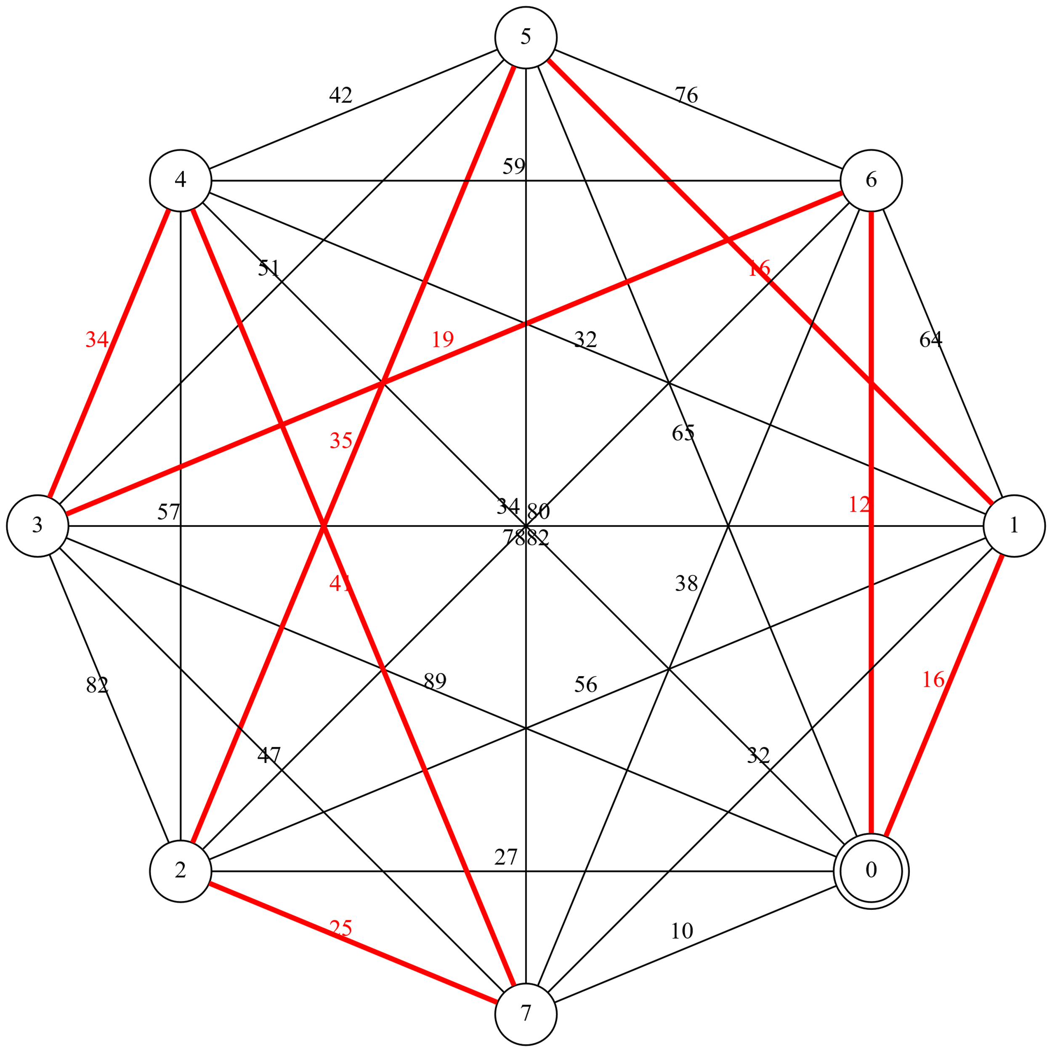

### *Test Case* 2:

|  |  |
| --- | --- |
| **Masukan** | **Keluaran** |
| 10  0 1 2 3 4 5 6 7 8 9  1 0 11 12 13 14 15 16 17 18  2 11 0 21 22 23 24 25 26 27  3 12 21 0 31 32 33 34 35 36  4 13 22 31 0 41 42 43 44 45  5 14 23 32 41 0 51 52 53 54  6 15 24 33 42 51 0 61 62 63  7 16 25 34 43 52 61 0 71 72  8 17 26 35 44 53 62 71 0 81  9 18 27 36 45 54 63 72 81 0 | Matrix:  inf 1 2 3 4 5 6 7 8 9  1 inf 11 12 13 14 15 16 17 18  2 11 inf 21 22 23 24 25 26 27  3 12 21 inf 31 32 33 34 35 36  4 13 22 31 inf 41 42 43 44 45  5 14 23 32 41 inf 51 52 53 54  6 15 24 33 42 51 inf 61 62 63  7 16 25 34 43 52 61 inf 71 72  8 17 26 35 44 53 62 71 inf 81  9 18 27 36 45 54 63 72 81 inf  Path: 0 -> 7 -> 3 -> 6 -> 4 -> 8 -> 2 -> 5 -> 1 -> 9 -> 0  Cost: 152.5  Elapsed time: 1573121 us  GraphViz file generated to ../usr/test_ctw_3.gv  Graph image generated to ../usr/test_ctw_3.png  Graph image generated to ../usr/test_ctw_3.svg |

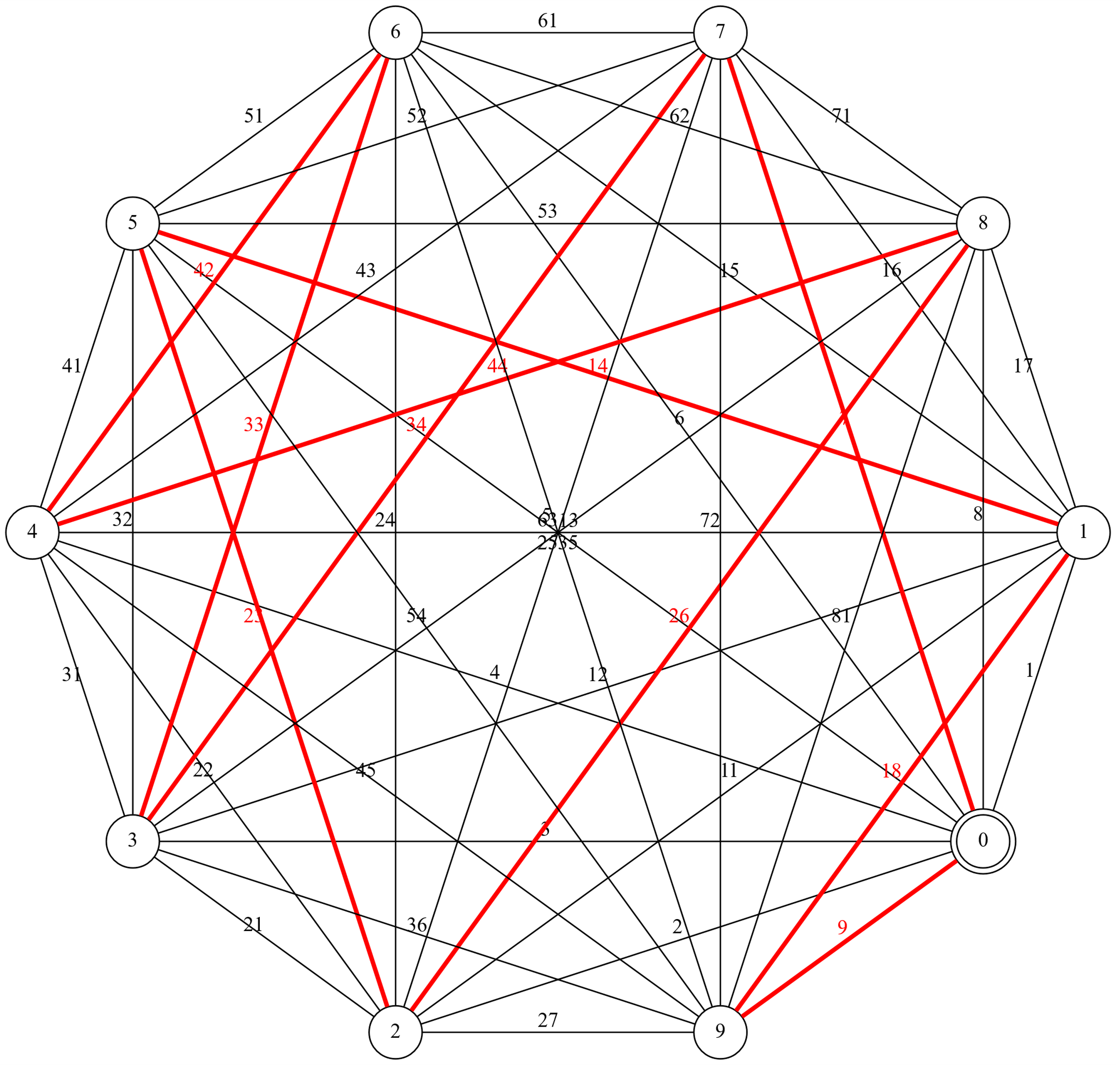

## *Reduced Cost Matrix*

### *Test Case* 1:

|  |  |
| --- | --- |
| **Masukan** | **Keluaran** |
| 8  0 16 27 89 34 65 12 10  23 0 56 78 32 16 64 32  36 19 0 82 57 35 80 25  70 25 79 0 34 51 19 47  34 25 65 50 0 42 59 41  35 90 26 10 37 0 76 82  37 64 63 27 35 59 0 38  37 80 28 38 58 39 41 0 | Matrix:  inf 16 27 89 34 65 12 10  23 inf 56 78 32 16 64 32  36 19 inf 82 57 35 80 25  70 25 79 inf 34 51 19 47  34 25 65 50 inf 42 59 41  35 90 26 10 37 inf 76 82  37 64 63 27 35 59 inf 38  37 80 28 38 58 39 41 inf  Path: 0 -> 7 -> 2 -> 1 -> 5 -> 3 -> 6 -> 4 -> 0  Cost: 171  Elapsed time: 0 us  GraphViz file generated to ../usr/test_rcm_2.gv  Graph image generated to ../usr/test_rcm_2.png  Graph image generated to ../usr/test_rcm_2.svg |

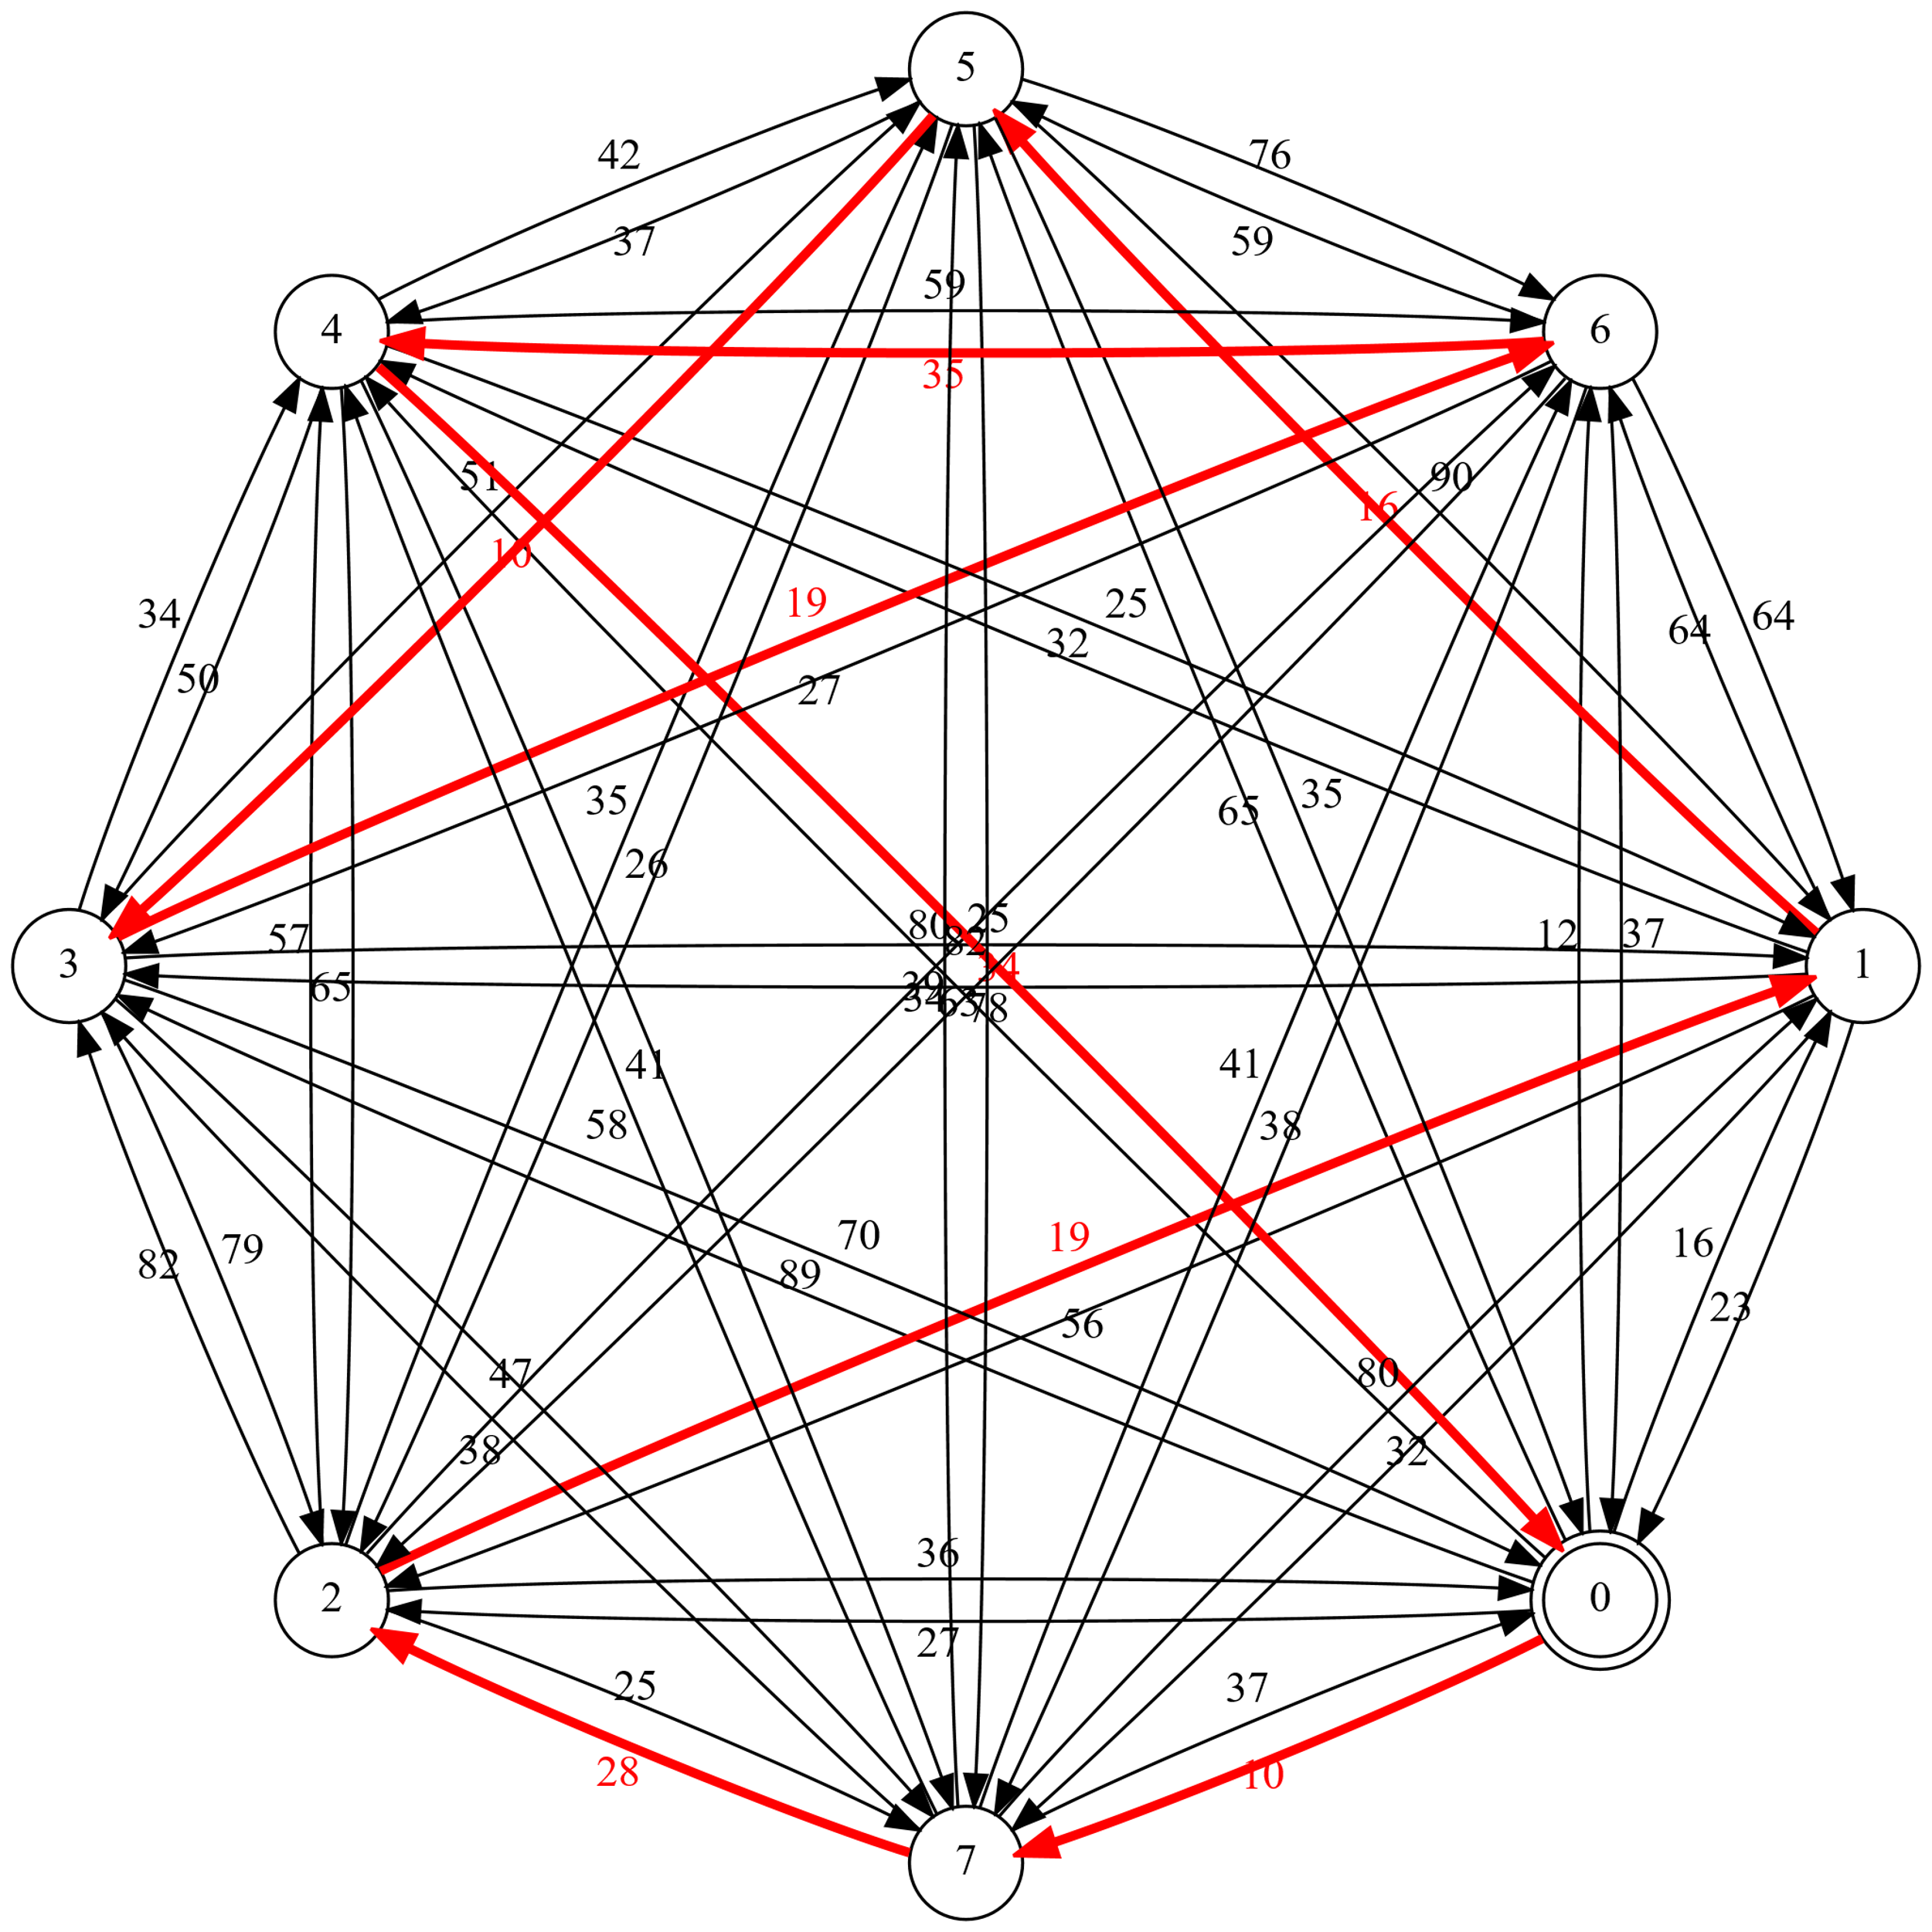

### *Test Case* 2:

|  |  |
| --- | --- |
| **Masukan** | **Keluaran** |
| 10  0 1 2 3 4 5 6 7 8 9  10 0 11 12 13 14 15 16 17 18  19 20 0 21 22 23 24 25 26 27  28 29 30 0 31 32 33 34 35 36  37 38 39 40 0 41 42 43 44 45  46 47 48 49 50 0 51 52 53 54  55 56 57 58 59 60 0 61 62 63  64 65 66 67 68 69 70 0 71 72  73 74 75 76 77 78 79 80 0 81  82 83 84 85 86 87 88 89 90 0 | Matrix:  inf 1 2 3 4 5 6 7 8 9  10 inf 11 12 13 14 15 16 17 18  19 20 inf 21 22 23 24 25 26 27  28 29 30 inf 31 32 33 34 35 36  37 38 39 40 inf 41 42 43 44 45  46 47 48 49 50 inf 51 52 53 54  55 56 57 58 59 60 inf 61 62 63  64 65 66 67 68 69 70 inf 71 72  73 74 75 76 77 78 79 80 inf 81  82 83 84 85 86 87 88 89 90 inf  Path: 0 -> 1 -> 2 -> 3 -> 4 -> 5 -> 6 -> 7 -> 8 -> 9 -> 0  Cost: 451  Elapsed time: 500 us  GraphViz file generated to ../usr/test_rcm_3.gv  Graph image generated to ../usr/test_rcm_3.png  Graph image generated to ../usr/test_rcm_3.svg |

